1. Perbandingan Sequential search, Sequential search(sorting), dan Binary search.
2. 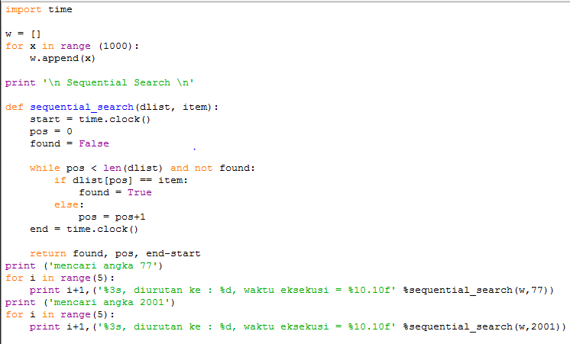Sequential Search

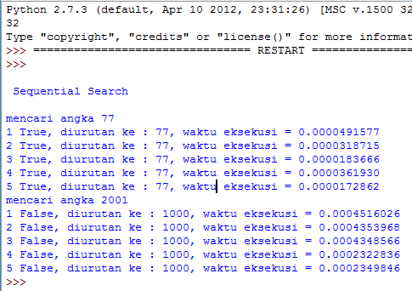**Hasil eksekusi >>>**

1. 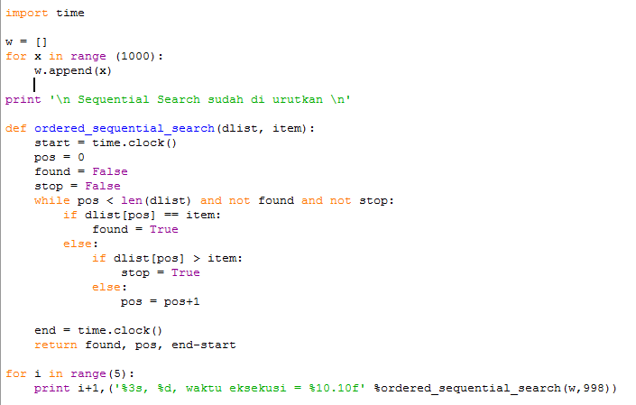Sequential sort (sorting)

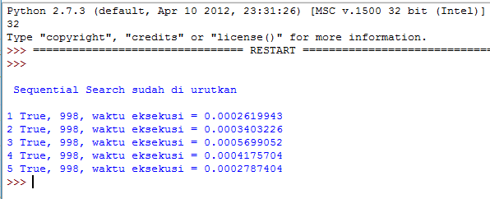**Hasil eksekusi >>>**

1. 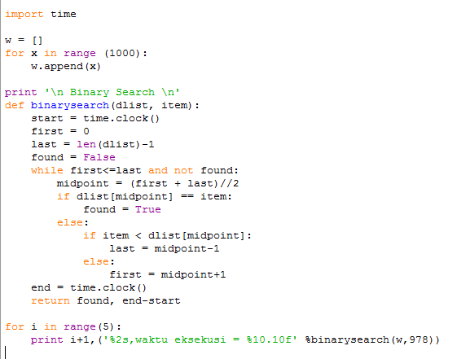Binary Search

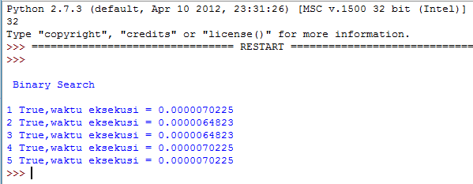**Hasil Eksekusi >>>**

1. Binary search rekursif

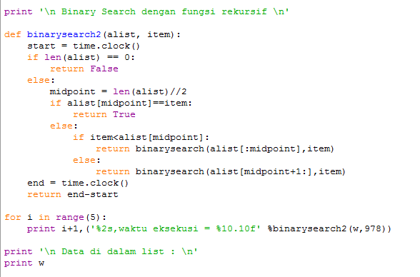

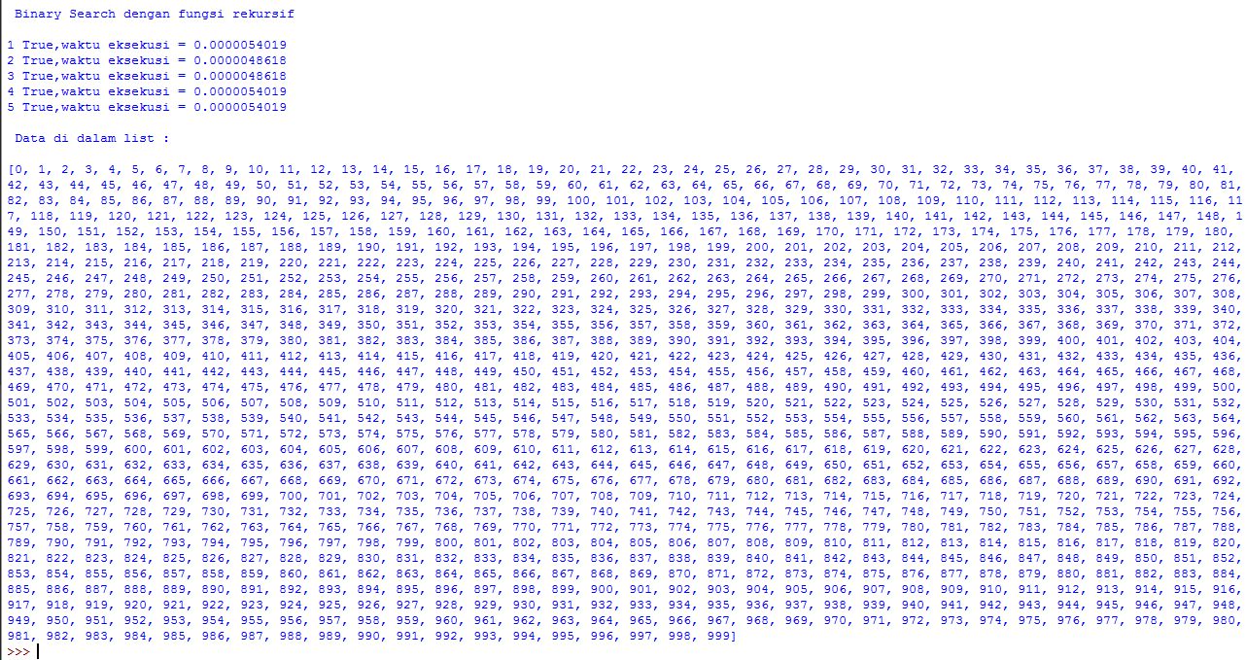**Hasil Eksekusi >>>**